Engineering Mechanics

Work Sheet 1

FY. K div Faculty: Sheba Varghese

Module 1

Q1. Resolve the force F=900 N acting at B as shown in figure into parallel component at O and A.

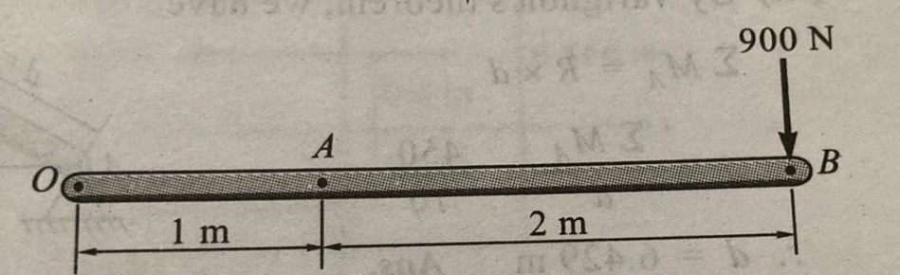

Q2. Determine the resultant of the parallel force as shown in figure and locate w.r.t O. radius is 1m.

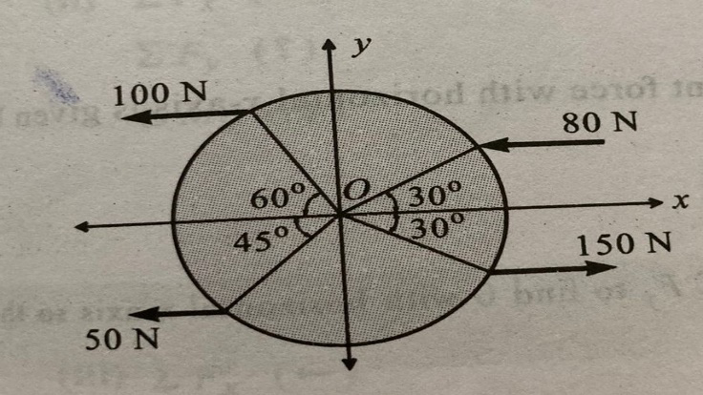

Q3. Replace the force system shown in the figure by a single force.

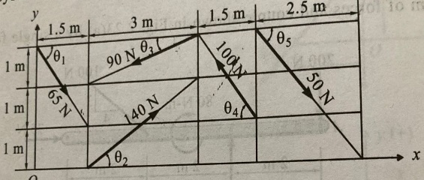

Q4. A triangular plate ABC is subjected to 4 coplanar forces as shown in the figure. Find the resultant completely and locate its position w.r.t point A.

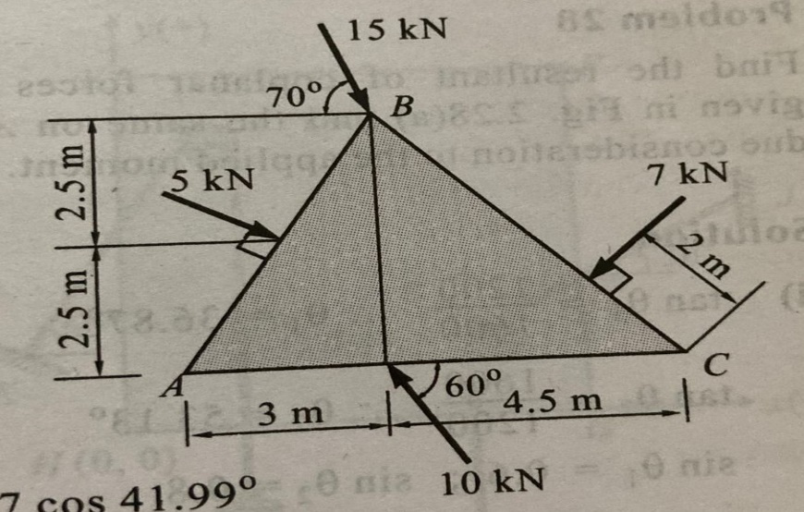

Q5. A machine component of length 2.5 m and height 1 metre is carried upstairs by 2 men, who hold it by the front and back edges of its lower face. If the machine component is inclined at 30 ̊ to the horizontal and weighs 100 N, find how much of the weight each man supports?

